*AN AWARD WINNER INTERNATIONAL ORGANIZATION*

A_



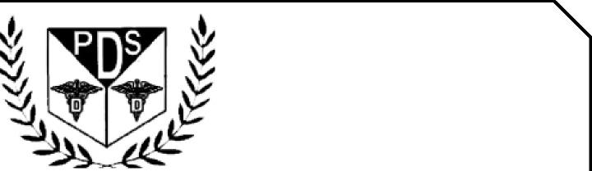

PROMOTING EXCELLENCE IN DENTAL EDUCATION   
Over 7000 Members Strong

**Presents**

A Must attend seminar for you and your staff

**ORAL SURGERY FOR GENERAL DENTIST**

**BY**

**DR JONE KIM**

**QUIET CANNON**



**On MARCH 30TH, 2025(Sunday) 9:00 am till 5:00 pm   
(CA Board 7 hrs C.E. units)   
at**

**901 VIA SAN CLEMENTE, MONTEBELLO, CA 90640**

(Please print in capital letters or attach your business card)

Name DR/RDH/RDA/DA Lic no

|  |  |  |  |
| --- | --- | --- | --- |
| Circle one First Middle Initial Last | |  |  |
| Address |  |  |  |

City State Zip

Cell no ________________ Accept text message yes/no E-Mail________________________________________

**ARE YOU A PDS MEMBER: YES/ NO**

***COMPLIMENTARY BREAKFAST, LUNCH & PARKING INCLUDED***

|  |  |  |
| --- | --- | --- |
| REGISTRATION FEE |  | ONE WEEK BEFORE |
| Dentists Non-members | $99.00 | $109.00 |
| Members | $89.00 | $99.00 |
| Hygienist/R.D.A. Non-members | $79.00 | $89.00 |
| Members | $69.00 | $79.00 |

FOR REGISTRATION

CALL TOLL FREE 1-866-422-5573 (1-866-4-CALL-PDS) OR 909-933-9076   
**TO REGISTER ONLINE VISIT US ON WWW** [**PDSOCIETY. COM**](http://PDSOCIETY.COM)

Make check payable to

Dr. R. Salwan

President



PDS

124 EAST F STREET SUITE #8 ONTARIO, CA 91764

Dr. D.P. Singh Nagra

Chairman



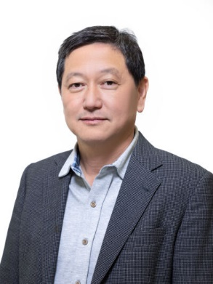

**Jone Kim. DDS, MS**

**Oral & Maxillofacial Surgery**

Dr. Jone Kim did his undergraduate study at UCLA and received his D.D.S. from UCLA School of Dentistry in 1994. He also received Master of Science (M.S.) in oral biology from UCLA Graduate School and completed his oral & maxillofacial surgery training from University Medical Center Fresno – UCLA in 1998. Currently, he is a lecturer and part-time faculty at UCLA Department of Oral & Maxillofacial Surgery and maintains a private practice in Southern California focusing on the surgical aspect of implant surgery. Dr. Kim is a Diplomate and board certified oral & maxillofacial surgeon by the American Board of Oral & Maxillofacial Surgery (ABOMS).

*Minimally Invasive Extraction & Predictable Bone Grafting Techniques*

* Basics & fundamentals of extraction
* Fundamentals of alveolar ridge healing
* Indications and rationale for RPBG
* RPBG technique
* Clinical cases of RPBG
* Indications and rationale for ridge expansion
* Difference between ridge expansion and ridge split
* Indications and rationale for ridge split
* Clinical cases

EVENT SPONSORED BY PUNJABI DENTAL SOCIETY AND DOWELL DENTAL